 | Assignment No. 01  SEMESTER Fall 2021  CS403- Database Management System | Total Marks: 20  Due Date: 13/12/2021
Instructions
Please read the following instructions carefully before solving & submitting assignment:
It should be clear that your assignment will not get any credit if:
- The assignment is submitted after due date.
- The submitted assignment does not open or file corrupt.
- The assignment is full or partially copied from (other student or ditto copy from handouts or internet).
- Student ID is not mentioned in the assignment File or name of file is other than student ID.
- The assignment is not submitted in .doc or .docx format.

Uploading instructions
Your submission must include:

- Assignment should be in .doc or .docx format.
- Save your assignment with your ID (e.g. bx020200786.doc).
- Assignment submission through email is NOT acceptable.

Objectives
The objective of this assignment is:
- To be able to understand basic concepts of Database, Conceptual Database Design and DFD.
Note:
Your answer must follow the below-given specifications.
- Font style: “Times New Roman”
- Font color: “Black”
- Font size: “12”
- Bold for heading only.
- Font in Italic is not allowed at all.
- No formatting or bullets are allowed to use.
- Your answer should be precise and to the point, avoid irrelevant detail.

Lectures Covered: This assignment covers Lectures: 1 to 9.
Deadline
Your assignment must be uploaded/submitted at or before 13/12/2021.

Question Statement:

Suppose you are required to model “Rent a vehicle” system for an organization to get complete understanding of the domain. System’s requirements in textual format is given below in paragraphs.
Registered users can rent out a vehicle for their common use. By using this system, users will also be able to know about different types of vehicles (cars, loaders, motorcycles, auto Rickshaw, van, bus, truck etc) available for rent at organization store. Users can view available vehicles under vehicle categories without registration, but only register users can send a booking request for an available vehicle with or without a driver (its user choice to rent a vehicle with or without driver). After getting confirmation from the manager, user will fill a rental agreement form which has all necessary details ( duration of hire, fuel detail, rental fee, The purpose of renting, return date, description of the rented vehicle, etc), he/she can select payment method via cash or online. User can view discounts/feedback. Users may also be able to post reviews/feedback.
The manager can add drivers, vehicle categories (transporter, non-transporter) and vehicle details (cars, loaders, motorcycles, auto Rickshaw, van, bus, truck etc), update vehicle and driver status as available or not available. He/She can view booking requests, confirm/ reject booking requests, view payment details. He/she can view feedback/ reviews and also add offers/discounts for their regular users.

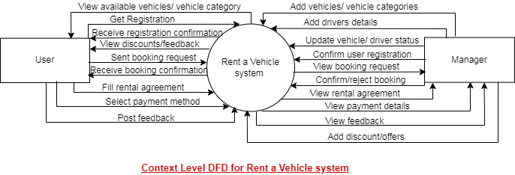

You are required to perform the following tasks according to the above scenario.

- Draw the level 0 Data Flow Diagram for the above given context level diagram.
- Identify Entities their attributes and primary keys from the above given scenario and fill out below given table.

Entities | Attributes | Primary Keys

=====================================Ended=======================================

For any query about the assignment, contact at CS403@vu.edu.pk

GOOD LUCK

